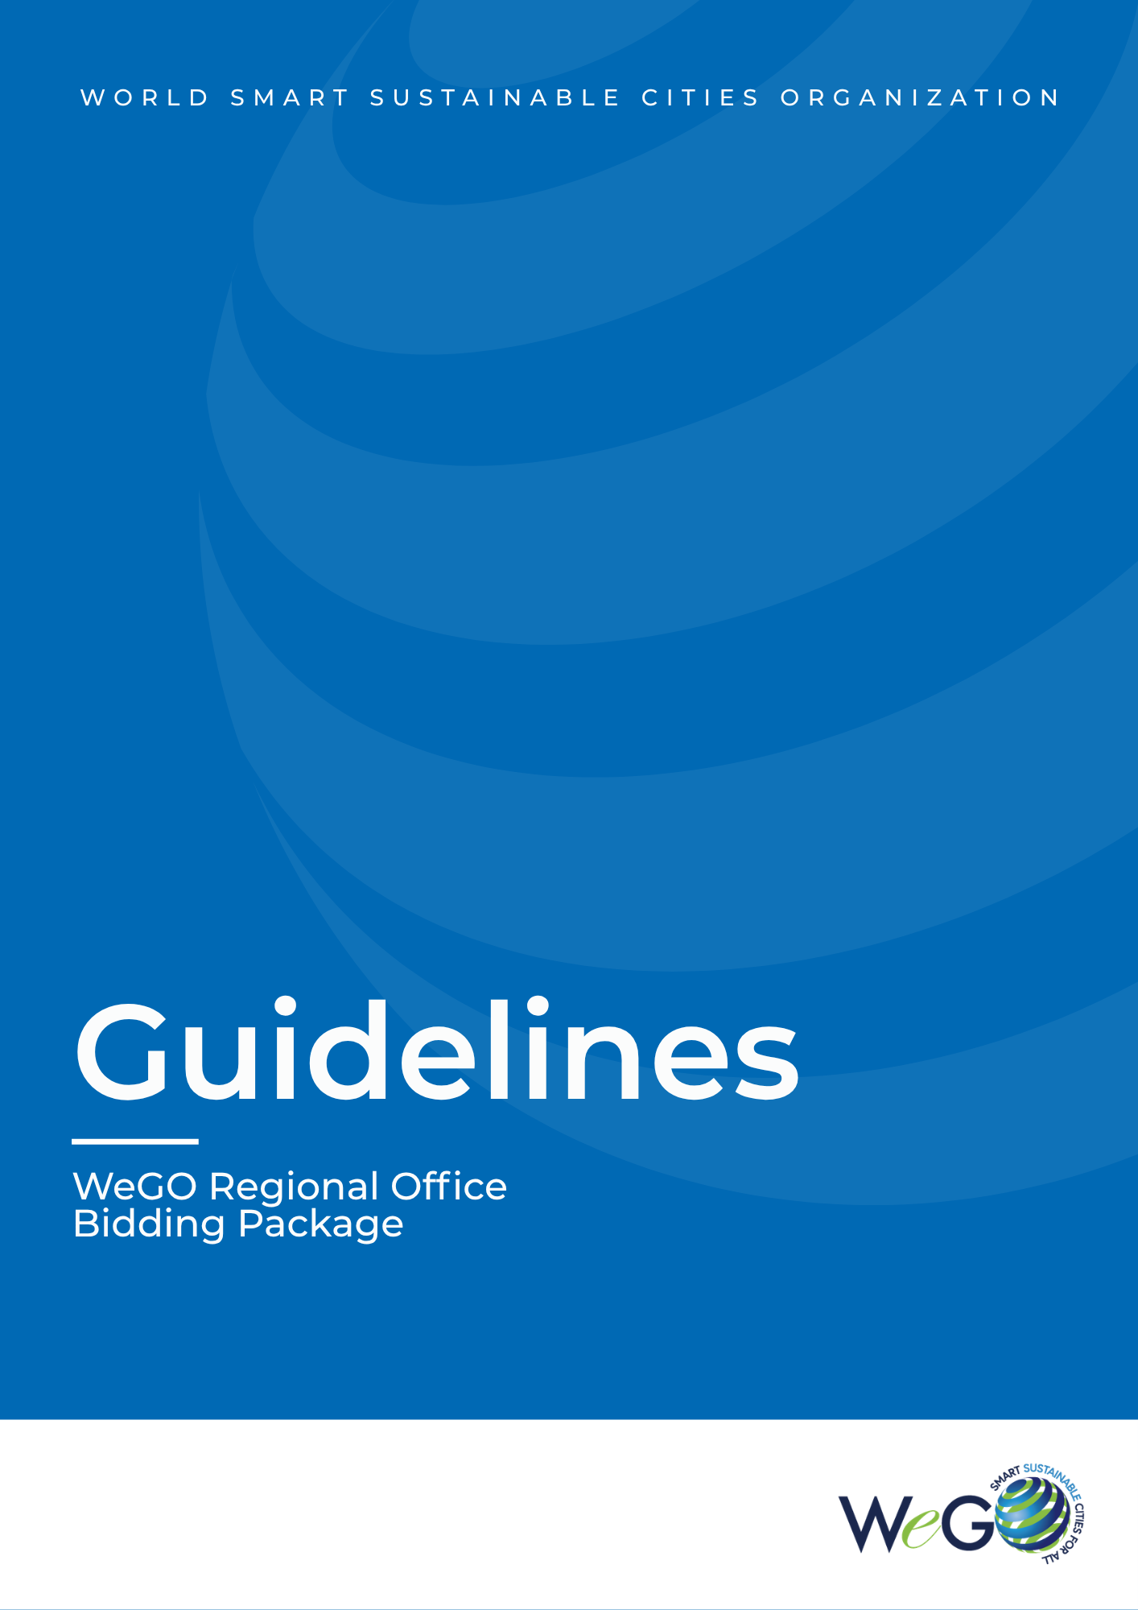



Guidelines for the WeGO Regional Office Bidding Package

WeGO members with an interest in establishing regional offices are strongly encouraged to complete the bidding package in accordance with these Guidelines and submit it to the WeGO Secretariat.


- Locations
WeGO Regional Offices have been established in the following regions: Africa, East Asia, Central Asia, Latin America and Middle East and North Africa. In 2026, the bids are open for WeGO members to host a regional office in Africa and Europe. Bids to host regional offices outside aforementioned regions are possible upon consultation with the WeGO Secretariat.

- Eligibility
Member cities of WeGO may apply to open and host a WeGO regional office in their city. Corporation and institution members shall ensure the local government's support and partnership through letters of commitment signed by the Mayor/Governor, prior to the bidding of the WeGO Regional Office.

- Bidding Package Components
  - Application Form (Annex A)
  - Letter of Oath (Annex B)
  - Proposal for the Establishment of a WeGO Regional Office (Annex C)
- Selection Procedures
  - The Executive Committee will evaluate the bidding package and approve/disapprove the establishment of the Regional Office at the Executive Committee meeting or by written consent.
  - In the event that two or more candidate cities submit a bidding package for the same region, the establishment of the Regional Office may be decided at a regular meeting of the Executive Committee or by written consent.
  - When the open call is made, interested cities should submit the prepared bidding package to the WeGO Secretariat at secretariat@we-gov.org at least one (1) month prior to the Executive Committee meeting at any given year. In 2026, the deadline for submitting bids is on July 17, 2026.
  - The bidding package with the WeGO Secretariat’s recommendations will be distributed to the Executive Committee members prior to the meeting.
  - Each applicant member city will present its bid at the meeting and thereafter, the Executive Committee members will discuss and approve or disapprove the establishment of the Regional Office.
  - In the event that the establishment of a Regional Office is decided by written consent, the WeGO Secretariat will circulate any bids collected to each Executive Committee member and request a final written decision.

- Announcement on the Approval of Regional Offices
Once a Regional Office has been approved by the Executive Committee, the results of the Regional Office selection will be announced to all member cities of WeGO after the Executive Committee meeting.

- Terms of Reference for the WeGO Regional Office
Each approved WeGO Regional Office will be required to abide by the provisions of the Terms of Reference for the WeGO Regional Office (hereinafter referred to as “TOR”). By submitting the bidding package, the applicant city is agreeing to abide by the TOR if its application is approved by the Executive Committee.

Guidelines for the WeGO Regional Office Bidding Package Annex A

Application Form

Region
- Name of Region:_____________________________________________________________________

✔ Note: Prospective office regions are Africa and Europe.
Other subdivisions of the mentioned regions are possible upon consultation with the WeGO Secretariat.

Applying Local Government
- Name of City (or Local Government):
- Name of the Representative (Mayor or equivalent):
- Incumbent term:

Applying Division or Department
- Name of Division (or Department):
- Office Address:
- Name of Head of Division:
- Email of Head of Division:

Partnering Entity (if applicable)
- Affiliation type:
- Official Name:
- Address:
- Phone:
- Email:

Corresponding Officer
- Name:
- Title:
- Phone:
- Email:

Name of City or Local Government hereby submits the Bidding Package in accordance with the Guidelines for the WeGO Regional Office Bidding Package and applies to establish a regional office of WeGO in Name of City or Local Government for the region of Name of Region.

For Name of City or Local Government, I hereby submit this application to the WeGO Secretariat.

______________
(Date: dd/mm/yy)

____________________________
(Signature of Mayor or equivalent)

_________________
(Name/Official Title)
Guidelines for the WeGO Regional Office Bidding Package Annex B

Letter of Oath

Name of Applicant Local Government
Address
Phone
Email

The applicant city hereby pledges to comply with the following commitments on the selection and establishment of the WeGO Regional Office.

- The applicant city will abide by the provisions of the WeGO Statutes concerning regional offices and the Terms of Reference for the WeGO Regional Office (hereinafter referred to as “TOR”). Among other things, the applicant city understands that:
- The WeGO Regional Office is an affiliated organization of the Secretariat that supports the functions of the Secretariat, facilitates the implementation of projects of the Organization, and manages members in the respective region;
- The Regional Office will serve for a term of five (5) years pursuant to the WeGO Statutes;
- All expenses required for setting up and operating the Regional Office will be borne by the applicant;
- The Regional Office will appoint a Regional Director, a Deputy Director, and have a team of at least two (2) other staff members;
- The Regional Office must be established within six (6) months of approval by the Executive Committee;
- The Executive Committee may decide to dissolve the Regional Office pursuant to annual assessments to be conducted under the TOR or in the event that the Executive Committee decides that the conduct, omission, or negligence of the Regional Office causes harm to the mission or purpose and/or reputation of WeGO.

- It is certified that all the documents presented to the WeGO Secretariat are true and complete and the applicant city will raise no objection to any measures taken by WeGO against the submission of false documentation or the delayed implementation of the applicant city’s proposal for the regional office without reasonable cause.

- The applicant city understands and agrees to abide by all provisions of the TOR and will make its best efforts to fulfill its role and responsibilities, as set forth in the TOR.

- The applicant city will abide by the decision of the Executive Committee regarding the approval of the establishment of the regional office and will comply with any request for additional documentation.

______________
(Date: dd/mm/yy)

____________________________
(Signature of Mayor or equivalent)

_________________
(Name / Official title)

Guidelines for the WeGO Regional Office Bidding Package Annex C

Proposal for the WeGO Regional Office

The Proposal for the Establishment of a Regional Office should include introductory information about the city or the local government and, if applicable, the partnering entity (corporation/institution/organization), along with an operating plan for the Regional Office, and expected benefits, among other requirements enlisted below. The proposal can be in a free form in Microsoft Word format but should not exceed 7 pages.

- Introduction to Your City or Local Government
- Background and Objectives
Explain the background and objectives for the establishment of a Regional Office in your city or local government.
- About Your City/Region
Describe basic information, including population and land area, and explain its geographical, economic, political, and social conditions.
- Smart Sustainable City Vision and Strategy
Briefly describe the overall vision and strategy highlighting in particular the ongoing strategies in the fields of smart sustainable city, innovation, and ICT. The description includes the organizational structure, budget, training programs, and policies of the division in charge (smart city, innovation, or ICT).
- Smart City Best Practice Projects
Briefly summarize an overview of the successful implementation of smart city related actions, if any.

- Operating Plan for the Regional Office
- Budget and Manpower for the Establishment of the Regional Office
Explain the plans and strategies for mobilizing funds and human resources for the establishment of the Regional Office, securing office space, and managing the manpower and budget. Include the proposed organizational structure of the Regional Office.
- Five (5)-Year Business Plan
Describe strategies to attract new members and manage current members in the region, promote the long-term sustainable development of the Regional Office and WeGO, raise funds, develop regular programs/activities, and promote exchanges and cooperation on smart sustainable city issues among other member cities in the region, along with any tentative plans to host a WeGO event or regular meeting, such as an Executive Committee Meeting or a General Assembly.

- Expected Benefits
Describe how the establishment of the Regional Office will promote the smart sustainable development of your city, bring economic impact to the region, and increase the region’s awareness of WeGO.

- Others
Explain any expected changes in the laws, regulations, and policies related to smart sustainable city and innovation development in your city or local government. In particular, describe the term of the incumbent mayor or equivalent and the date of forthcoming elections.

- Date of Establishment
Set forth a detailed timeline for the establishment of the Regional Office. The Regional Office should be opened within six (6) months after receiving the approval of the Executive Committee.

